**Year 9 Chemistry 2023 History of the Atom Validation Assessment Name: _____________________**

**Instructions**: Examine the table below and answer the questions in the spaces provided

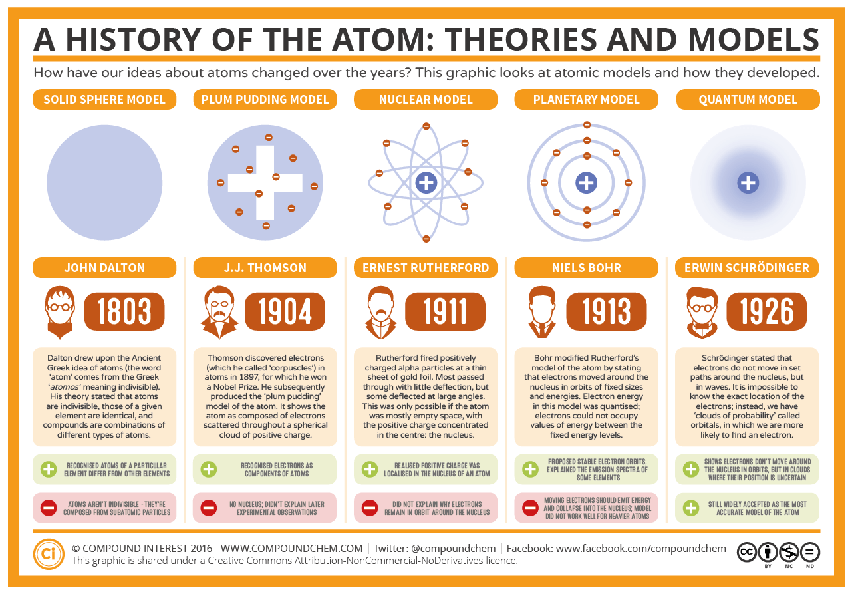

**Question 1:** Which scientist produced the “plum pudding” model of the atom?

_______________________________________________________________ (1 mark)

**Question 2:** What is the Greek word for “atom”?

______________________________________ (1 mark)

**Question 3:** What was the name of the model created by “Niels Bohr”? (1 mark)

_______________________________________________________

**Question 4:** Which scientist fired positively charged alpha particles at a thin sheet of gold? (1 mark)

___________________________________________________

**Question 5**: In 1926, the scientist stated that the electrons move in ______________________ (1 mark)

**Question 6**: Rutherford discovered that the nucleus of the atom was _________________________ charged.

(1 mark)

**Question 7**: Which model is still widely accepted by scientist?

____________________________________________________ (1 mark)

**Question 8**: How many electrons are in the first layer around the nucleus in the Planetary Model?

______________ (1 mark)

**Question 9:** How many years was it between the first and last model? (1 marks)

**Question 10:** Write down the date and URL (1 mark)

Date: ___________ URL: ____________________________________________________